Downtown Adjacent Residential Overlay District
(A) Purpose. The purpose of these standards is to maintain a high quality, walkable, safe built environment, in keeping with traditional patterns of neighborhood development.
(B) Applicability. The requirements of this district shall apply to all new construction within the district boundaries. Additionally, any existing property wherein the cost of renovations reaches 60 percent or greater of the appraised value of the principal building shall be redeveloped in accordance with the requirements of this chapter.
In the case of a fire or natural disaster, the property owner will have the option to rebuild to existing conditions before the disaster as long as a permit is requested within 6 months of occurrence.

[i] District Boundaries

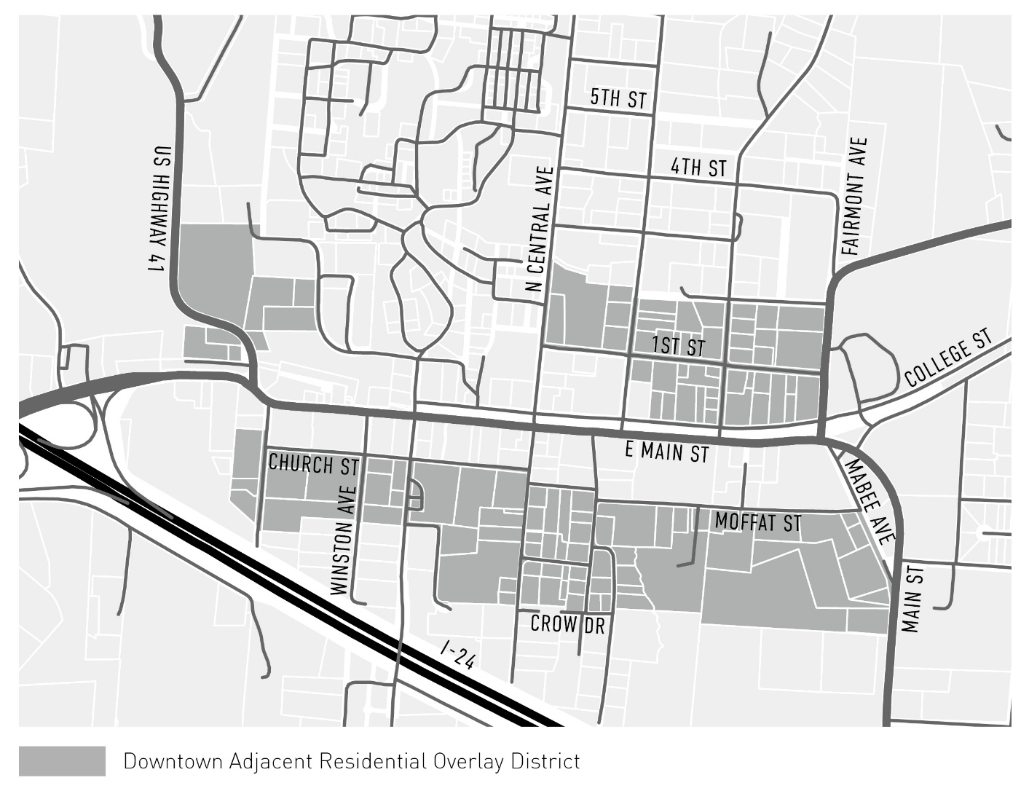
(C) Permitted Uses
RESIDENTIAL USES | Permitted
Apartments and condominiums* | l
Accessory Dwelling Units | l
Customary home occupations | l
Duplexes | l
Group quarters, dormitories | l
Mixed-use residential* | l
Mobile homes, double-wide | l
Mobile homes, single-wide
Mobile home parks
Patio homes | l
Single-family dwellings | l
Temporary dwelling units | l
Tiny houses
Townhouses | l

(D) Dimensional Standards:
DIMENSION
Front yard setback | 20 feet
Rear yard setback (standard) | 5 feet
Rear yard setback (when abutting a  public street) | Equal to the front yard setback required for  adjacent properties fronting the rear street
Side yard setback (standard) | 5 feet
Side yard abutting a local street,  alley, or cul-de-sac | 10 feet
Side yard abutting a major  thoroughfare or collector road | 15 feet
Minimum lot size:  Public water + sewer  Public water + septic system  Private well + septic system | 1,500 ft²  20,000 ft²  25,000 ft²
Maximum lot coverage | 60%
Minimum lot width | 25 feet
Maximum building height | 3 stories or  40 feet
Maximum Accessory Building Height | See Section 502
Minimum square footage of welling unit | 650 SF

Relationship of building to street

1. Primary Building Placement & Massing:
- The primary building on each parcel shall be placed as close to the street as possible when facing a public right of way, within the applicable setbacks.
- All buildings shall have a maximum width of 40’ at the street and a maximum depth of 70’.
- All buildings shall provide an average 9 feet ceiling height for first floor.
  - All buildings shall provide a minimum finish floor elevation of 1’ and a maximum finish floor elevation of 5’ above grade at the front of the building. Relief from finished floor elevation requirements may be permitted upon presenting topographic hardship for the lot.
2. Accessory Building Placement & Massing:
- See Section 502 for Accessory Dwelling Unit requirements.

3. Front Porches & Stoops:
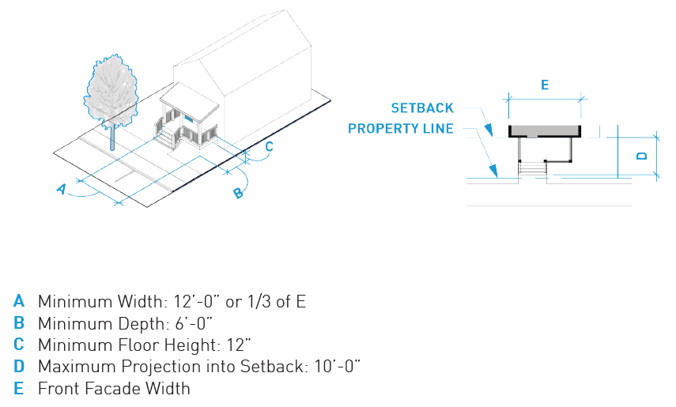
- Front porches and/or stoops on the façade of the primary building shall be required. Front porches are required when a majority of homes on the block face have porches. Otherwise, stoops are required.
- Front porches, when required, shall:
- Be a minimum of 12 feet wide or one-third the width of the front façade, whichever is less, and a minimum of six feet deep.
- Contain roofs.
- Provide steps accessible from the sidewalk and/or public right of way.
- Be raised at least 12 inches above the adjacent grade for a primary street facing residence.
- Stoops, when required, shall:
  - Be covered or un-covered and stairs may run to the front or to the side.
  - Have a 4 feet width minimum from the principal façade to the inside of the column face for stoops with a covered landing.
  - Have a maximum height of 96 inches.
  - Have a maximum of 12-foot length for each individual building entrance or group of connected entrances. The pedestrian connection from the stoop to the public sidewalk shall be allowed to run from the door along the facade of the building, parallel to the street, for a maximum of 12 feet, before connecting directly to the public sidewalk.
- For parcels with more than one street frontage, the front porch and stoop requirements shall only be required for the building façade located in the primary front yard of the parcel.
- Porches and stoops shall be permitted to extend into the front setback a maximum of 10 feet. No conditioned space is permitted above any porches that project into front setbacks.

4. Front doors:
- Front doors shall face and be visible from the adjacent street for primary buildings facing a public right of way. Primary buildings should be oriented so that the front or primary facade should be parallel to its adjacent street.
- Secondary units shall have a front door clearly visible from a sidewalk or walkway extending onto the lot.
- A street address number shall be located directly above or adjacent to the primary building entrance, should be clearly visible from the sidewalk and should be a minimum of six inches in height.

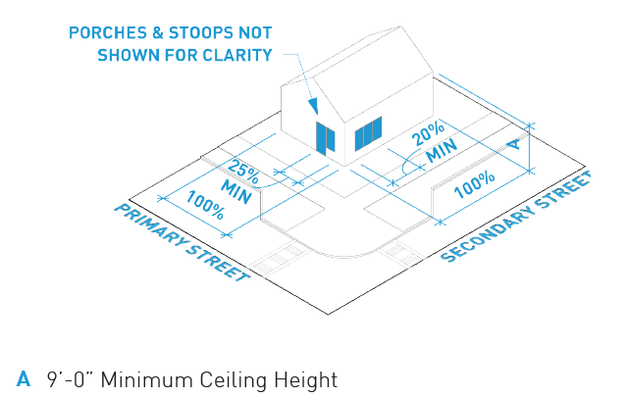
5. Facade fenestration:
- Façade fenestration (windows and may include doors) shall be a minimum of 25% of the length of the façade along the ground floor of primary street facing facades, and shall be a minimum of 20% for secondary street facing facades.
- Window fenestration for upper stories shall be a minimum of 15% of the length of the facade for all street facing facades.
- No more than 10’ in length of any street facing façade may be blank without fenestration provided.

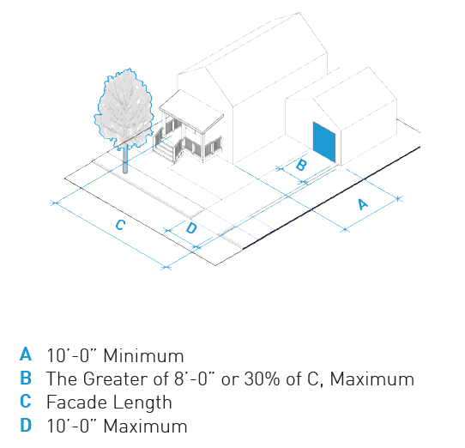
6. Garages:
- When side or rear vehicle access is feasible, front-facing garages are not permitted.
- If front-facing garages are permitted:
  - Front-facing garage doors shall be recessed and located a minimum distance of ten feet behind the front façade of the principal structure. For parcels with more than one street frontage, front-facing garage doors shall be defined as those facing the front yard of the parcel, and not side yard, or rear yard.

SITE STANDARDS

1. Parking:
- One parking space per unit is required. On-street parking, when present, may count towards minimum parking requirements.
- Except for driveways, parking off-street shall not be located between a building and the street.
- Drives serving a single parcel should have a maximum width of 10 feet with a maximum apron flare of 30 inches.

2. Fences and Walls:
- Fences or walls at the side or rear property line shall not exceed 72 inches.
- Fences or walls placed in the front yard or along a right-of-way should not exceed 48 inches and shall provide a minimum of 50% transparency.
- Barbed wire, plastic slats, plastic screening fabric, and chain link fences are not permitted.
- Retaining walls.
  - Maximum height. Retaining walls in the front yard are limited to four (4) feet in height. A retaining wall located adjacent to a sidewalk along a public street shall not exceed two (2) feet in height. Retaining walls shall be limited to eight (8) feet in height within interior side and rear yards.
  - Administrative variations from these wall height requirements shall be permissible if topographic hardship can be demonstrated.

3. Equipment Limitations:
- Utility meters, air conditioning equipment, permanent grills, permanent swimming pools, recreation and play equipment, doghouses and dog runs, hot tubs and spas and wood decks (except for boardwalks from the front gate to the front porch which may be up to five feet wide) shall not be installed between a building and the street.
- Antenna and satellite dishes shall not be installed between a building and the street when a sufficient signal is available elsewhere. Antennas or satellite dishes more than one meter in diameter should not be installed.

